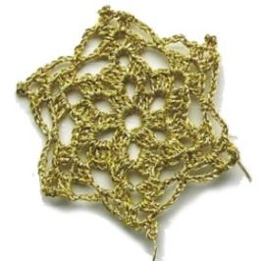
Nostalgija - 17th Days of Kaštela’s Tradition – KAŠTELA 2026.
KAŠTEL NOVI, 26th to 29th of June 2026.
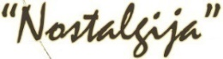
ECO-ETHNO FAIR KAŠTELA 2026

ECO-ETHNO FAIR from 26th - 29th of June 2026.
Daily from 17:00 – 23:00 (Riva/Seafront)

Program 26th - 29th of June 2026.

June 26

20:00 Opening of the Eco-Ethnic and Island Products Fair with a special program

21:00 Fashion show of the Traditional costumes and Designers

June 27

17:00 – 23:00 Eco-Ethnic and Island Products Fair

21:00 Folklore County Festival

June 28

17:00 – 23:00 Eco-Ethnic and Island Products Fair

20:30 Evening of Spiritual Chansone

June 29

17:00 – 23:00 Eco-Ethnic and Island Products fair

All events are FREE – We look forward to welcoming you!

Organised by: Tourist Board of Kaštela
Co-organizer: City of Kaštela, Association Šušur, Parish of Saint Peter the Apostle

Supported by: City of Kaštela, Ministry of Tourism and Sports, Ministry of Regional Development and EU Funds, Ministry of Agriculture, Split-Dalmatia County, Tourist Board of Split-Dalmatia County, Cemex.

Media sponsors: TV Jadran, TV Dalmacija, Portal grada Kaštela, Kaštelanski šušur, Kaštela.com, Dalmacija Danas, Slobodna Dalmacija, Croatia.hr

